STP Test Case # ST-2
Requirements Tested: FR-6.2: The system shall continue loading available home page components after a non-critical failure.
Build/Release #: v0.1.0_20260304
Determination: SUCCESSFUL
Setup:
1. Open the Chrome browser on Mac OS.
2. Navigate to front-facing Moxie server (http://moxie.cs.oswego.edu:7000/)
3. Execute test.
Execution:
1. Navigate to the Homepage.
2. Open Developer Tools: Right click any element and select Inspect.
3. Go to the Network Tab: Click the Network tab in the top menu of the panel. 4. Enable Throttling: Locate the dropdown menu that says No throttling near the top right of the network pane.
5. Select Speed Profile: Click the dropdown and each option, such as:
- Fast 4G: Simulates a decent 4G connection.
- Slow 4G: Simulates a poor 4G connection.
- Decent 3G simulation
6. Reload the Page: Refresh the page to see the effect of the throttled speed.
6. Observe the status and any system feedback.

Expected Result:
- The homepage loads for the student even if a non-critical component fails, and the remaining components display normally without preventing page functionality.

Actual Result:
- The system successfully goes through each simulation and works for all cases. All the components were displayed normally.
Screenshot:
Go to network - check “no throttling”
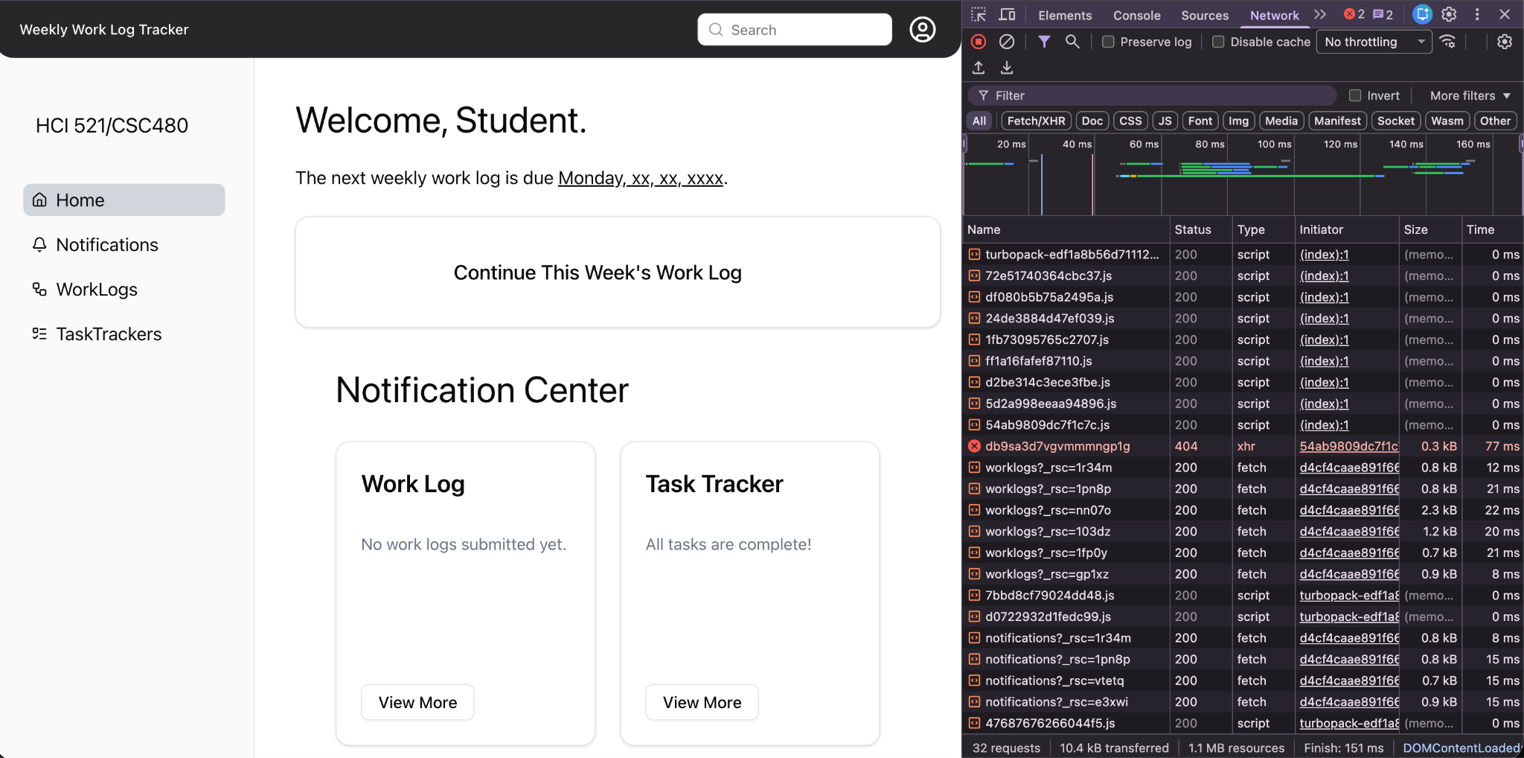

- Fast 4G connection.
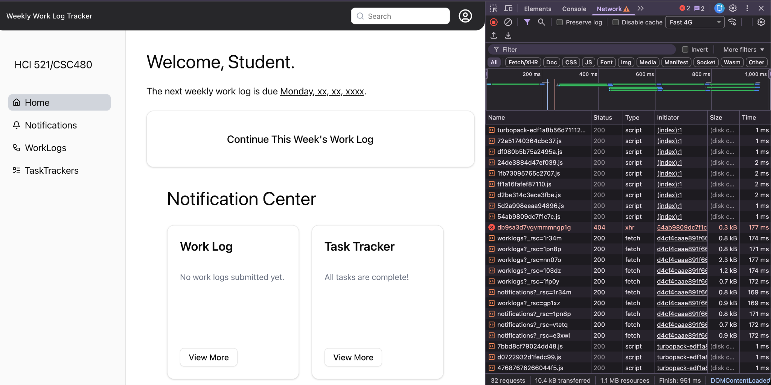
- Slow 4G connection.
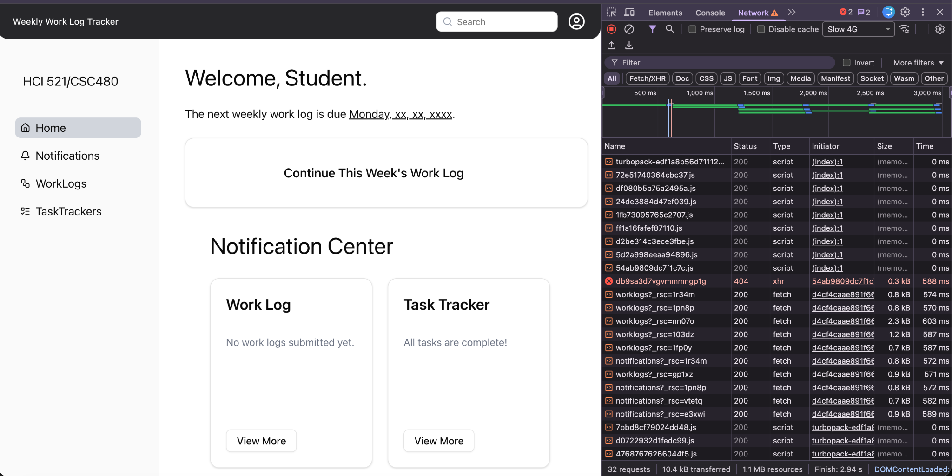

- Decent 3G connection.
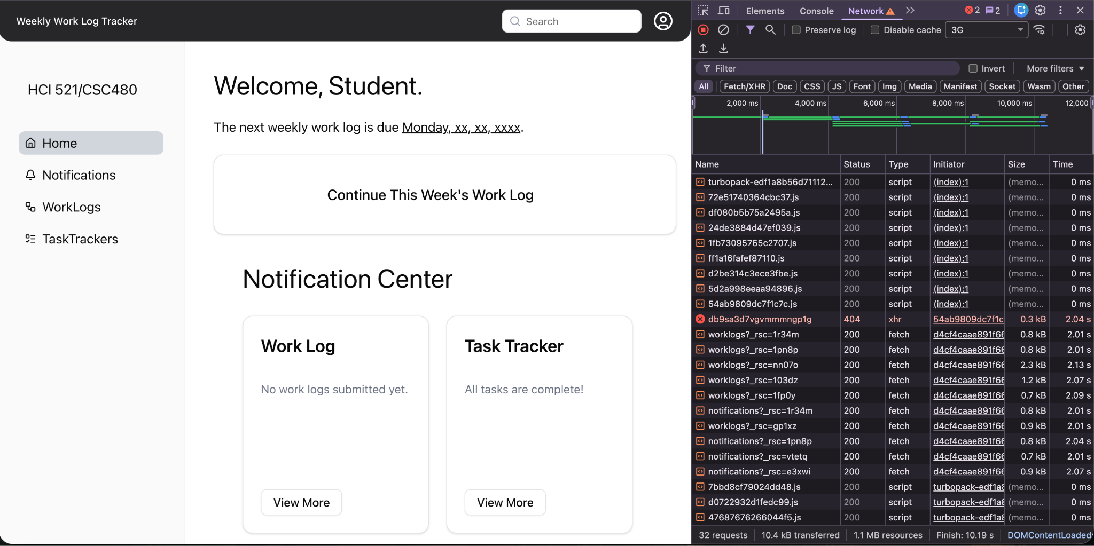

STP Test Case # ST-2
Requirements Tested: FR-6.3: The system shall display an error message when critical home page data cannot be loaded.
Build/Release #: v0.1.0_20260304
Determination: SUCCESSFUL
Setup:
1. Open the Chrome browser on Mac OS.
2. Navigate to front-facing Moxie server (http://moxie.cs.oswego.edu:7000/)
3. Execute test.
Execution:
1. Navigate to the Homepage.
2. Open Developer Tools: Right click any element and select Inspect.
3. Go to the Network Tab: Click the Network tab in the top menu of the panel. 4. Enable Throttling: Locate the dropdown menu that says “No throttling” near the top right.
5. Click the dropdown : Offline- Simulates no internet connection.
6. Reload the Page: Refresh the page to see the effect.
6. Observe if the home page loads and displays an error.
Expected Result:
- If critical home page data cannot be loaded, the system should display a clear error message to the student indicating the issue.
Actual Result:
- The system successfully showed error.

Screenshot:
